August 23, 2026 Name________________________

Home Is Where The Heart Is

- Printed Text

2 Timothy 1:1- 6 (KJV); 2 Timothy 3:14 -16 (KJV)

1. Circle Paul’s titles in the following Scripture below.

Whereunto I am appointed a preacher,

and an apostle, and a teacher of

the Gentiles. 2 Timothy 1:11 (KJV)

2. The definition of the Greek word apostle is one who has been called and
commissioned for a specific task, and sent on the mission with full authority of the sender.

_____________________________________________________

________________________________________________________

2 Timothy 1:1 (KJV)
Paul, an apostle of Jesus Christ by the will of God,
according to the promise of life which is in Christ Jesus,

3. Give the relationship between Paul and Timothy.

a. Timothy was Paul’s nephew. b. Timothy was Paul’s biological son.

c. None of the above
(#3 Scripture Reference next page.)
2 Timothy 1:2 (KJV)
To Timothy, my dearly beloved son:
Grace, mercy, and peace, from God the Father and Christ Jesus our Lord.

4. In the following Scripture, what did Paul remember to do when he thought
about Timothy?

_________________________________________________________________

2 Timothy 1:3 (KJV)
I thank God, whom I serve from my forefathers with pure conscience,
that without ceasing I have remembrance of thee in my prayers night and day;

5. Where was Paul when he wrote the second letter to Timothy?

a. In prison b. In Barnabus’ house c. In his house in Jerusalem

2 Timothy 1:8 (KJV)
Be not thou therefore ashamed of the testimony of our Lord,
nor of me his prisoner: but be thou partaker of the afflictions
of the gospel according to the power of God;

6. Why do you think Paul wanted to see Timothy?

______________________________________________________

______________________________________________________

2 Timothy 1:4 (KJV)
Greatly desiring to see thee, being mindful of thy tears, that I may be filled with joy;

7. Do you think Timothy came from a Christian home?

______________________________________________________

______________________________________________________

2 Timothy 1:5 (KJV)
When I call to remembrance the unfeigned faith that is in thee,
which dwelt first in thy grandmother Lois,
and thy mother Eunice; and I am persuaded that in thee also.
8. Where do you think Timothy received the gift to preach and teach?

a. from Paul b. from the Holy Spirit

c. from the Elders of his local church congregation

2 Timothy 1:6 (KJV)
Wherefore I put thee in remembrance
that thou stir up the gift of God, which is in thee by the putting on of my hands.

9. Place a √ mark beside the Scripture that indicates things Paul was
instructing Timothy to do. Place an X beside the Scripture that indicates
things Paul was instructing Timothy not to do.

_______ Be not thou therefore ashamed of the testimony of our
Lord, nor of me his prisoner: but be thou partaker of the
afflictions of the gospel according to the power of God;
2 Timothy 1:8 (KJV)

_______ Thou therefore endure hardness, as a good soldier of
Jesus Christ. 2 Timothy 2:3 (KJV)

_______ Study to shew thyself approved unto God, a workman
that needeth not to be ashamed, rightly dividing the word of
truth. 2 Timothy 2:15 (KJV)

_______ But continue thou in the things which thou hast learned
and hast been assured of, knowing of whom thou hast
learned them; 2 Timothy 3:14 (KJV)

10. Give one of the major advantages of knowing the Scriptures.

_________________________

2 Timothy 3:15 (KJV)
And that from a child thou hast known the holy scriptures,
which are able to make thee wise unto salvation
through faith which is in Christ Jesus.
11. The inspired, written, Word of God teaches us …

a. How to be s_________.

b. How to l________ after we are s_________.

2 Timothy 3:16 (KJV)
All scripture is given by inspiration of God,
and is profitable for doctrine, for reproof, for correction, for instruction in righteousness:

12. Give the names of the books in the New Testament where Paul’s and
Timothy’s names appear in the introductions of the books.

a. ______________________ b. ______________________

c. _____________________ d. ______________________

e. _____________________

2 Corinthians 1:1 (KJV)
Paul, an apostle of Jesus Christ by the will of God, and Timothy our brother, unto the church of God which is at Corinth, with all the saints which are in all Achaia:

Philippians 1:1 (KJV)
Paul and Timotheus, the servants of Jesus Christ, to all the saints in Christ Jesus which are at Philippi, with the bishops and deacons:

Colossians 1:1 (KJV)
Paul, an apostle of Jesus Christ by the will of God, and Timotheus our brother,

1 Thessalonians 1:1 (KJV)
Paul, and Silvanus, and Timotheus, unto the church of the Thessalonians which is in God the Father and in the Lord Jesus Christ: Grace be unto you, and peace, from God our Father, and the Lord Jesus Christ.

2 Thessalonians 1:1 (KJV)
Paul, and Silvanus, and Timotheus, unto the church of the Thessalonians in God our Father and the Lord Jesus Christ:

Philemon 1:1 (KJV)
Paul, a prisoner of Jesus Christ, and Timothy our brother, unto Philemon our dearly beloved, and fellowlabourer,

PRINTED TEXT

2 Timothy 1:1-6 (KJV)

¹ Paul, an apostle of Jesus Christ by the will of God, according to the promise of life which is in Christ Jesus,

² To Timothy, my dearly beloved son: Grace, mercy, and peace, from God the Father and Christ Jesus our Lord.

³ I thank God, whom I serve from my forefathers with pure conscience, that without ceasing I have remembrance of thee in my prayers night and day;

⁴ Greatly desiring to see thee, being mindful of thy tears, that I may be filled with joy;

⁵ When I call to remembrance the unfeigned faith that is in thee, which dwelt first in thy grandmother Lois, and thy mother Eunice; and I am persuaded that in thee also.

⁶ Wherefore I put thee in remembrance that thou stir up the gift of God, which is in thee by the putting on of my hands.

2 Timothy 3:14-16 (KJV)

¹⁴ But continue thou in the things which thou hast learned and hast been assured of, knowing of whom thou hast learned them;

¹⁵ And that from a child thou hast known the holy scriptures, which are able to make thee wise unto salvation through faith which is in Christ Jesus.

¹⁶ All scripture is given by inspiration of God, and is profitable for doctrine, for reproof, for correction, for instruction in righteousness:
Abbreviated Geographical Chronology of Paul

By: Deacon Henry L. Goines, Th.D.

Persecute the church in Jerusalem (Acts 8:1)
Preaches the Gospel in Damascus days after his conversion (Acts 9:19-20)
Leaves Damascus and goes to Arabia (Galatians 1:17)
Leaves Arabia and returns to Damascus (Galatians 1:17)
Escape to Jerusalem (Acts 9:23-26)
Escape to Caesarea enroute to Tarsus (Acts 9:30)
Barnabus goes to Tarsus to bring Paul to Antioch of Syria (Acts 11:25)
Barnabas and Paul goes on the first missionary journey (Acts 13:2-3)
(John Mark was with Barnabas and Paul during a portion of this mission)
John Mark leaves the mission in Perga and returns to Jerusalem (Acts 13:13)
Paul and Barnabus returned to Antioch of Syria (Acts 14:26)
Paul and Barnabus goes to Jerusalem to settle a dispute (Acts 15:2)
Paul and Barnabus returned to Antioch of Syria (Acts 15:2)
Paul and Silas goes on a second missionary journey (Acts 15:40)
Timothy joins this missionary journey at Lystra (Acts 16:1)
Paul and Silas beaten and placed in jail at Philippi (Acts 16:12 23)
Paul sent Timothy to minister in Philippi (Philippians 2:19)
Silas and Timothy ministering in Berea (Acts 17:13-14)
Paul goes to Athens call for Silas and Timothy (Acts 17:15)
Paul sent Timothy to minister in Thessalonica (1 Thessalonians 3:2)
Paul goes to Corinth (Acts 18:1)
Silas and Timothy joins Paul in Corinth (Acts 18:5)
Paul sent Timothy to minister in Corinth (1 Corinthians 4:17)
Paul sent Timothy to minister in Corinth (1 Corinthians 16:10-11)
Silas and Timothy preached in Corinth (2 Corinthians 1:19)
Timothy ministering in Macedonia (Acts 19:22)
Timothy was with Paul at Troas (Acts 20:4-5)
Timothy spent time in jail. (Hebrews 13:23)
Paul wrote a letter to Timothy (1 Timothy 1:2)
Paul returns to Jerusalem (Acts 21:17)
Paul in prison in Caesarea (Acts 23:33)
Paul under house arrest in Rome (Acts 28:16)
Paul released from house arrest in Rome (Acts 28:30)
Paul arrested in Rome (2 Timothy 4:9-13)
Paul wrote a second letter to Timothy (2 Timothy 1:2)
Some of the Places Paul Visited

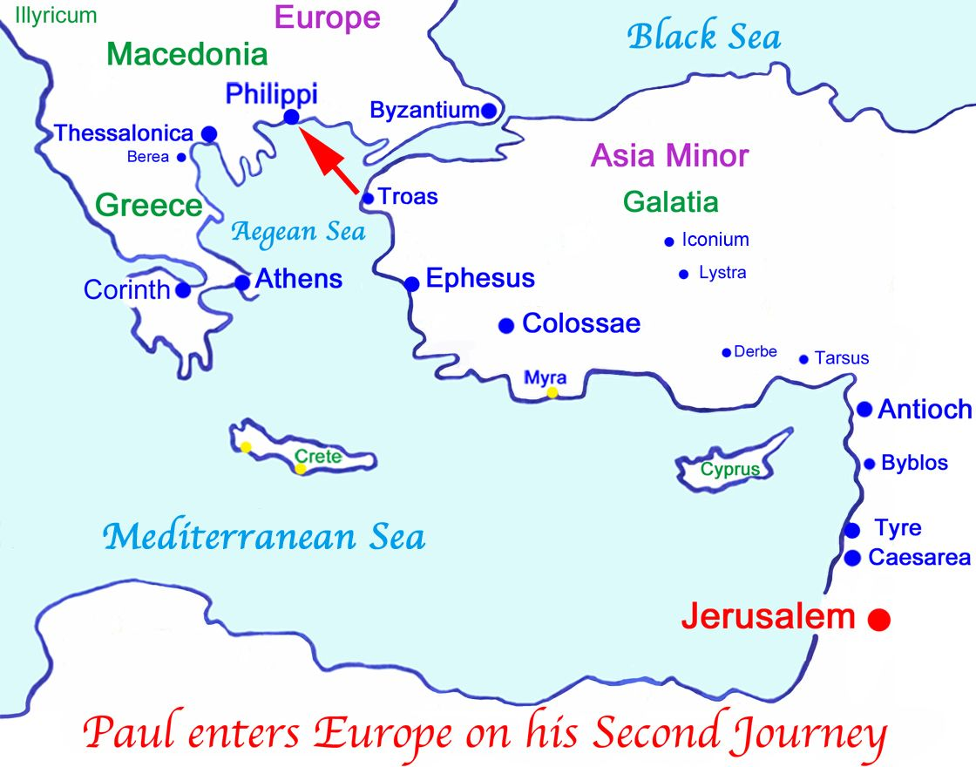

Deacon Henry L. Goines, Th.D., Teacher brothergoines@aol.com
Adult Teacher, Higher Ground Fellowship Hour (225) 938-4230 (Text)
Mount Pilgrim Baptist Church

Reading Assignment

2 Timothy Chapter 4

I have read 2 Timothy chapter 4.

My favorite verse is 2 Timothy 4: _____

Student’s Full Name _______________________

Date _________________

Exegetical Comments on
2 Timothy chapter 4 Verse _______

___________________________________________________

___________________________________________________________

___________________________________________________________

___________________________________________________________

___________________________________________________________

___________________________________________________________

brothergoines@aol.com
(225) 938-4230 (Text)

Deacon Henry L. Goines, Th.D., Teacher
Adult Teacher, Higher Ground Fellowship Hour
Mount Pilgrim

